**GCC SD Toolkit**

To start the toolkit, login to your ASGA hop and double-click the toolkit shortcut, which looks like a Scottish guy.

 The kit will take a few moments to load, bear with it!

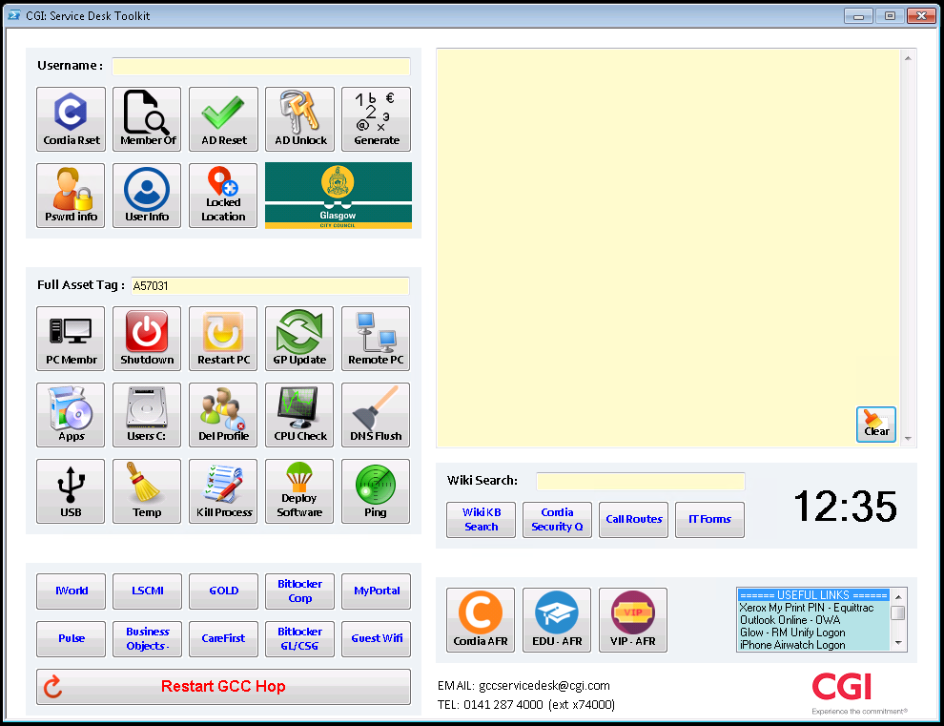

**User Functions**

This section performs functions upon user accounts found in active directory.

Functions are performed on any account name entered into the ‘username’ input box.



|  |  |
| --- | --- |
| **Cordia // VPN Type Password Reset** | |
| * Resets the password for the account username in the Username text field. * Password is randomly generated and displayed in the output box. * Does **NOT** make the user change their password on next login. |  |

|  |  |
| --- | --- |
| **Member Of** | |
| * Provides a list of groups that the selected user is a member of. |  |

|  |  |
| --- | --- |
| **Active Directory Password Reset** | |
| * Resets the password for the account username in the Username text field. * Password is randomly generated and displayed in the output box. * User **MUST** change their password on next login. |  |

|  |  |
| --- | --- |
| **Active Directory Account Unlock** | |
| * Unlocks the account named in the Username text field. |  |

|  |  |
| --- | --- |
| **Generate Password** | |
| * Generates a random password, displays it in the output box and copies it to the clipboard for pasting. |  |

|  |  |
| --- | --- |
| **Password Information** | |
| * Provides user password information including, last time the password was changed, never expires status, account lock period, bad password count, account creation date and bad login attempts. |  |

|  |  |
| --- | --- |
| **User Information** | |
| * Provides user account information including full name, email address, creation date, home drive path, account enabled and department. |  |

|  |  |
| --- | --- |
| **User Locked Location** | |
| * Queries domain controllers to ascertain the location of a locked user account. Useful if a user is having issues logging in due to being already logged into another device within GCC. |  |

**Asset Functions**

This section performs functions upon assets found in active directory.

Functions are performed on any asset tag entered into the ‘full asset tag’ input box.



|  |  |
| --- | --- |
| **PC Member of Groups** | |
| * **This function lists the groups an asset is a member of.** * **Similar to finding the asset in Active Directory and opening the ‘Member of..’ tab.** |  |

|  |  |
| --- | --- |
| **Asset Shutdown** | |
| * **Shuts down an asset.** |  |

|  |  |
| --- | --- |
| **Asset Restart** | |
| * **Restarts an asset.** |  |

|  |  |
| --- | --- |
| **Asset GP Update & DNS Flush** | |
| * **Remotely performs a GP update** and DNS Flush **on the chosen asset. Takes a few seconds and the user will get a popup to say that the update has been performed.** * **Performs a DNS Flush on the selected asset remotely.** * **This is the same as remoting to the device and using the command line “ipconfig /flushdns”** and “gpupdate/force”**.** * **Useful if the users cached DNS records are poisoned or incorrect and their browser is showing incorrect website data or credentials.** * **This will remove the records, allowing new ones to be recorded when a user re-visits a website.** * For example, if the *google.co.uk*  record was poisoned and redirecting you to a strange website, flushing the DNS is a good first step to getting the regular ​*google.co.uk* back again. |  |

|  |  |
| --- | --- |
| **Remote to Asset** | |
| * **Starts a remote session with the chosen asset. Uses the Remote Control Viewer in Windows and will take partial asset tags or full.** |  |

|  |  |
| --- | --- |
| **List Applications Installed on Asset** | |
| * **Lists all applications installed on the selected asset.** |  |

|  |  |
| --- | --- |
| **C$ Remote** | |
| * **Opens a Windows Explorer box straight to the assets C:\ drive.** |  |

|  |  |
| --- | --- |
| **Remove User Profile from Asset** | |
| * **Used to delete a user’s local profile, stored on a selected asset.** * ***User must be logged out first.*** * Firstly, enter a username AND asset tag and hit the Del Profile button. * A batch file will run and remove the profile from the asset. * Once finished have the user log back in**.** |  |

|  |  |
| --- | --- |
| **PC Performance Check** | |
| * **Provides a report on the selected asset, which brings back information like:**   + **User logged in**   + **CPU clock speed**   + **Temp folder size**   + **Uptime**   + **OS version, service packs and 32bit/64bit information.**   + **Device make/model if registered**   + **IPv6 address**   + **IPv4 address**   + **Attached storage drives, their size, usage and free space**   + **Top 5 running processes listed by memory usage** |  |

|  |  |
| --- | --- |
| **Attached USB Devices** | |
| * **This function provides a list of USB ports, description and their connected devices.** |  |

|  |  |
| --- | --- |
| **Clear Temp Folder** | |
| * **Clears the temp folder from the affected asset.** * **Useful if the C:\ drive is nearing full, as this can create some space.** * **These are files created temporarily and not used for any further purpose.** * Once clicked a batch file will open and remove all temp files from the device. |  |

|  |  |
| --- | --- |
| **Kill Process** | |
| * **Kills the process currently taking the most CPU processing power on an asset.** * **Can be used on a non-responsive device if an application is taking too long to respond or stopping usage of the asset.** * ***Running ‘CPU Check’ (PC Performance Check) function above, to see the current top 5 list of processes is advised first.*** |  |

|  |  |
| --- | --- |
| **Deploy Software via Active Directory** | |
| * **Adds the device to an application group, thus installing the application on the device.** * **Similar to adding a group to the asset’s ‘Member of…’ tab in Active Directory.** * **To use, enter the asset tag in the ‘Full Asset Tag’ text field and click Deploy Software. Once the asset has been found you will be asked to enter the software package name. This is the package name given by the SAM team when installation has been validated through Remedy.** * **Package example: APPD_Firefox_Current_Version_M32** * ***This function will check for duplicate assets (I.e. Two assets with similar tags e.g. SWSA76754 & FINA76754), the correct package name has been entered and also if it is already installed. In which case, Active Directory may need to be consulted to proceed with installation.*** |  |

|  |  |
| --- | --- |
| **Comms Check Device** | |
| * **Pings the device to check network connectivity and delays.** * Also runs Tracert and DNS Lookup. Results are saved to a text file and displayed. * This information can be added to a ticket in Remedy for the comms team, should a call be network related. * **Provides network packet timings.** * **Also provides the current IP address of the asset.** |  |

**Application Links**

This section provides a range of links to applications used by GCC SD to aid users on calls.

Each button will open the application/URL in the current browser.

|  |  |
| --- | --- |
| **GCC Links Section – Current List** | |
| * **IWorld** * **LSCMI** * **GOLD** * **Bitlocker Recovery Corp** * **Myportal** * **Pulse** | * **SAP Business Objects (BI Launchpad)** * **Carefirst** * **Bitlocker Recovery GL** * **Cisco Guest Wifi Admin** |
|  | |
|  | |

**AFR Lists**Each AFR button will open the current list of AFR users for one of the sections Cordia/Education/VIP



These lists are opened from ASGA56690 and need to be updated there, when the lists change.

**Useful Links**This is a list of useful URLs to applications/webpages used with either GCC SD or for GCC users. When an option is clicked within the list, the corresponding URL is output and copied to the clipboard for pasting.

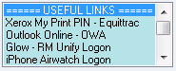

Example URLs: Equitrac, Outlook OWA, SAP Fiori login.

**Restart Hop Server**Clicking this button will restart your hop. This should only be done if the hop is slow or not responding as it should etc. The function will ask you to confirm this before restarting the operating system. Please make sure to close any applications firstly, if this is an option.



**Wiki Search**Entering your search terms in to the ‘Wiki Search’ text field and hitting enter will open the GCC Wiki Knowledge Base and automatically apply your search query.



Example: For information on SAP Fiori, type ‘fiori’ into the box, hit enter and GCC KB will be displayed with the relevant information.

**Output Box**Most functions within the toolkit will output important information to this box. Some functions will copy the requested information to your clipboard too.

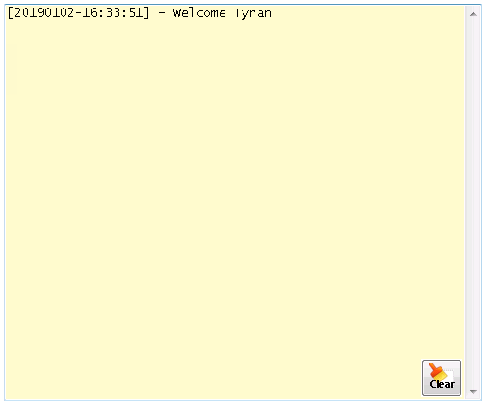

The clear button in the bottom right of the output box will remove all text from this box and clear it.